SARS Alpine Equipment Recommendations Chart

**Several factors beyond age go into ski length and boot flex including weight, height, skiing ability, and aggressive nature of athlete. For additional help, check with one of your coaches and or one of the sales representatives from the Alpine Shop
**U10 and U12 youth athletes using multi event skis can be used for GS one year and moved to slalom the next year as they grow.

 | STARS - U8 | U10 | U12 | U14 | U16 and UP
Helmet | Hard-ear Helmet | Hard-ear Helmet | Hard-ear Helmet | Hard-ear Helmet- FIS certified | Hard-ear Helmet - FIS certified
Skis | One pair of All mountain / multi-event skis  Approximately nose high | 1 set Multi-event Skis  Or, SL and GS length for the series competitor  (option- traditional mounted free skis) | SL Jr Race Skis (nose high)  GS Jr Race Skis (top of head high)  Recommended traditional mounted skis | SL Race Skis  GS Race Skis  SG Race Skis  All Mountain/Free Skis | SL Race Skis  GS Race Skis  SG Race Skis  DH Race Skis  All Mountain/Free Skis
Poles | Fitted Poles | Fitted Poles | SL Poles with Pole Guards  GS Poles | SL Poles with Pole Guards  GS Poles | SL Poles with Pole Guards  GS Poles
Boots | 3 or 4 buckle boot | 4-buckle boot | Jr Race Boot | Race Boot | Race Boot
Extended Equip. | No speed suit or SL specific equipment | Speed suit option SL specific equipment at coaches’ recommendation | Speed Suit  Shin Guards  SL Helmet Bar | Speed Suit  Shin Guards  Back Protector SL Helmet Bar | Speed suit  Shin Guards  Back Protector  SL Helmet Bar

Examples:
Hard Ear Helmet: SARS participants must have a full-coverage, hard-ear ski helmet. Make sure the helmet fits correctly and conforms to USSA and/or FIS certification requirements!

Multi-Event Race Ski: This is a less expensive option compared to event-specific skis but still offers the stability and maneuverability required to participate in YSL-level slalom, giant slalom, and kombi events.

Four buckle Race boots: These boots offer the fit and support athletes will need for all-mountain skiing and racing. Be careful not to get a boot that is too big or too stiff.
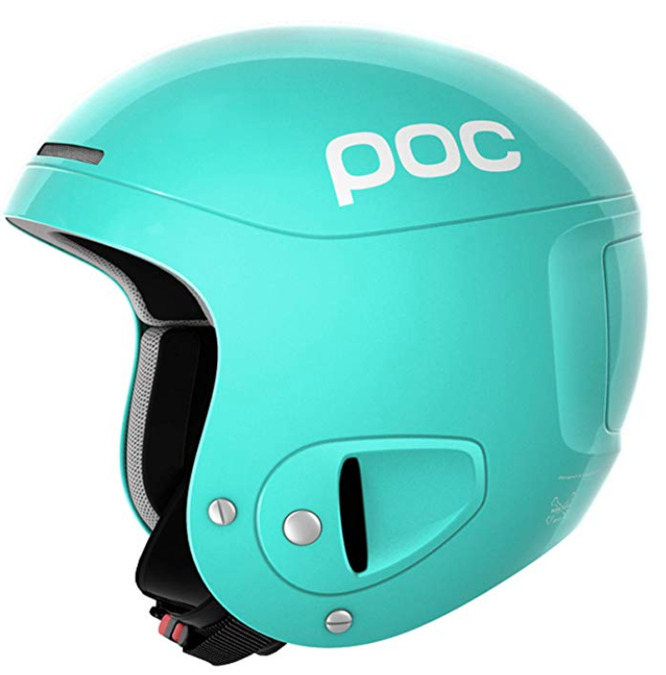
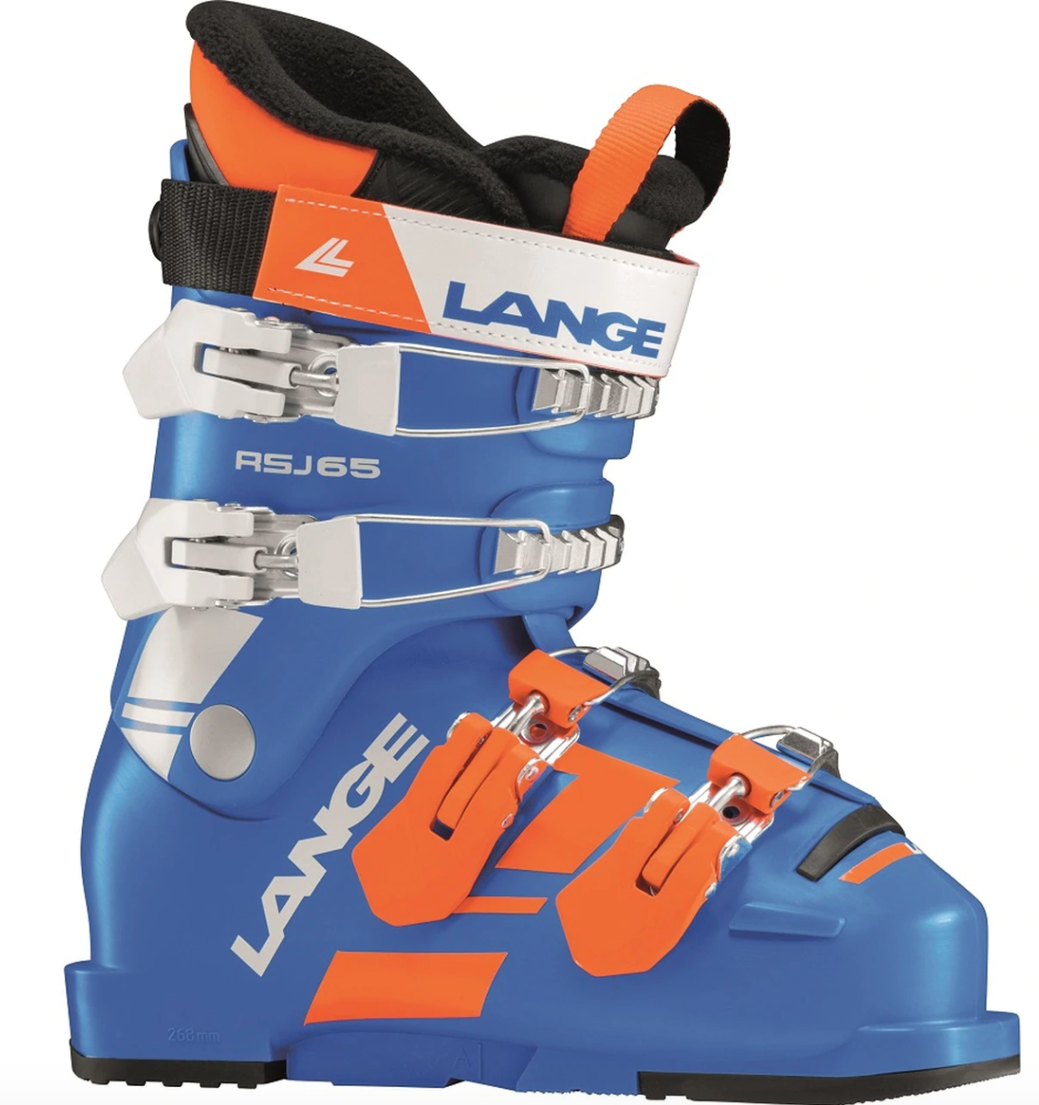
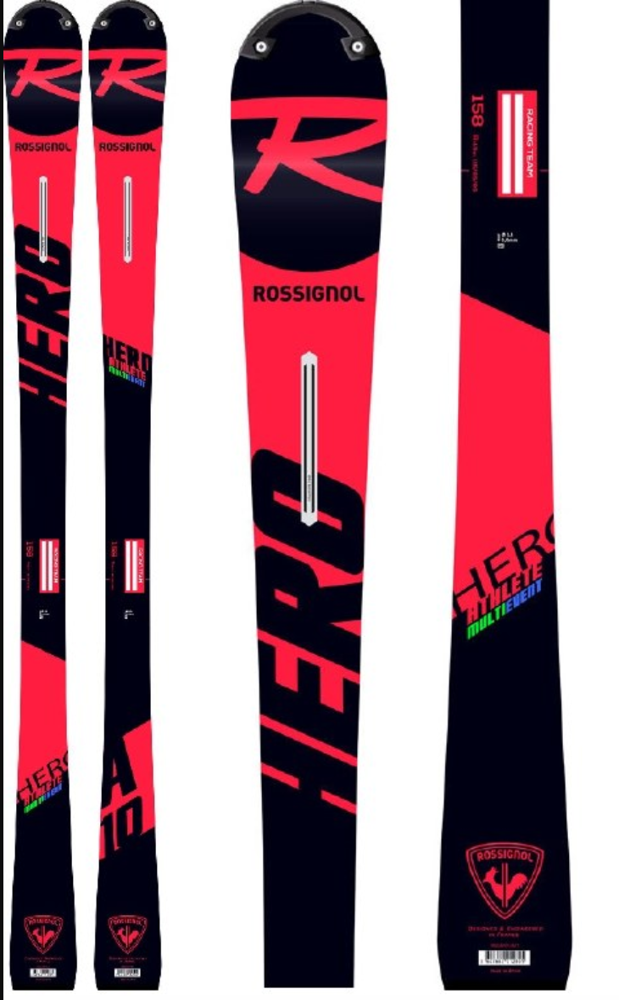

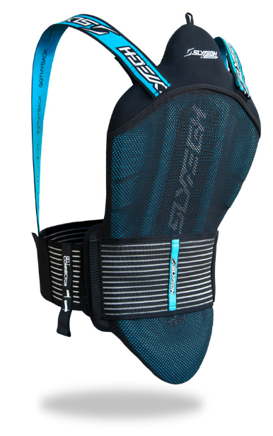
Extended Equipment: More advanced athletes will need slalom poles that incorporate protective pole guards as well as shin guards. Back protector for more protection during high levels.
